ALGORITHM FOR THE PREDICTION ON THE ICFES SABER PRO EXAM RESULTS
Samuel Ceballos Posada  Universidad Eafit  Colombia  sceballosp@eafit.edu.co | Pedro Botero Aristizábal  Universidad Eafit  Colombia  pboteroa@eafit.edu.co | Mauricio Toro  Universidad Eafit  Colombia  mtorobe@eafit.edu.co

SUMMARY
Para escribirlo pueden dar respuesta a estas preguntas: ¿Cuál es el problema?, ¿Por qué es importante el problema?, ¿Qué problemas relacionados hay?
The Icfes Saber Pro Exam is a test that every student who is part of a university has to do in order to graduate. This exam, although not helping much for the professional future of the student, is a way for universities to understand their weaknesses and look for the points I which they should focus their academic programs.
The algorithm uses previous information and exams to predict how each student will do on the Saber Pro, by analyzing their result on the Icfes exam made at the end of High School and other information collected including family wealthness, time using technology devices, city of living, etc. and putting the students on certain group using classification that determine how good he/she will do on the exam. This algorithm has previously been used by Universities in other countries to look for further ways of improvement on their curriculums.

1. INTRODUCTION
Universities operate in a very competitive environment, they are constantly confronting other institutions in order to attract the best students and making sure they stay. Also, the Saber Pro exam results play an important factor in university rankings, so they care a lot about student performance.
It is a fact that universities collect a lot of data from each student when they are applying. More specifically, universities in Colombia ask for the results of the ICFES exam, which is never used again after the student is accepted in the institution. With the implementation of a decision tree algorithm, universities could use the data from the ICFES exam to determine how a student will perform in the Saber Pro exam. This way universities could see what are the areas in which students struggle the most, thus make adjustments to their curriculum in order to improve performance in the exam.

2. PROBLEM
The main objective of this project is to establish an algorithm that is able to predict how a person will do on the ICFES Saber Pro exam based on information that includes habits, results on previous exams and basic information.
The solution of this project will help universities to discover where their weaknesses are at and try to implement new techniques to help their students grow better on those aspects.

3. SIMILAR WORK

3.1 ID3
The ID3 algorithm, also known as Iterative Dichotomiser 3 is a recursive algorithm invented by Ross Quinlan in 1975, used to generate a decision tree from a fixed set of examples attempting to create the smallest tree possible. The resulting tree is used to classify future samples. It is most commonly used in machine learning and natural language processing.
ID3 works with the following steps:
- Calculate the entropy of the attributes.
- Calculate the Information Gain for the attributes, then split the set into subsets using the attribute with the minimum entropy.
- Find the attribute with the maximum information gain.
- Recourse until the desired tree is found.
For example, the table is a data set of factors to play tennis outside, which produces the following tree:
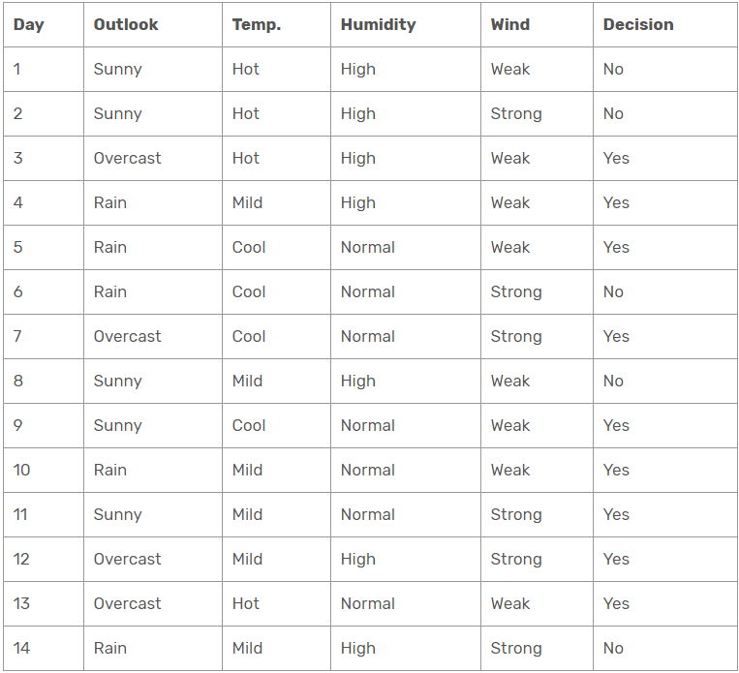
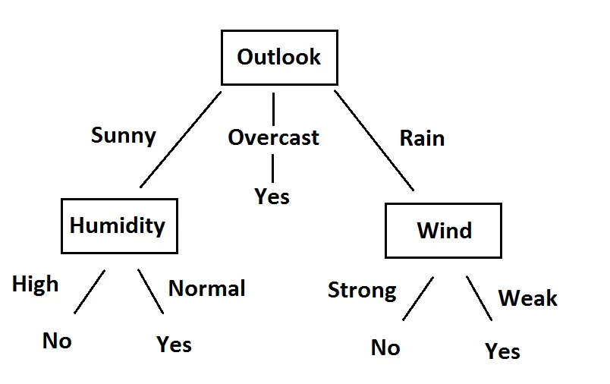
Even though ID3 is the most common decision tree algorithm, it has some disadvantages. For example, all attributes must be nominal values, the data set cannot have missing data and the algorithm tends to fall into overfitting.

3.2 C4.5
C4.5 is another algorithm created by Ross Quinlan based on ID3. It generates a decision tree where each node splits the classes based on the Information Gain. The attribute with the highest Information gain is used as the splitting criteria, just like ID3.
The main difference between the two is that C4.5 can use discrete and continuous attributes and it can handle missing attribute values.

3.3 CART
First introduced by Leo Breiman during the 1980’s. The CART algorithm, also known as Classification And Regression Algorithm, is used to predict results based on different types of modeling problems. Due to its simplicity, it is commonly known as a decision tree, but recently many platforms have started to use the term CART when referring to it. This algorithm is commonly used as a foundation for more advanced algorithms, like bagged decision trees, random forest and boosted decision trees.
The CART model is represented by a binary tree. Where each root node holds an input variable which splits into boolean values (True or False). Then, the leaf node contains output variables which are the ones used to make a prediction on the data. The purity of the model can be tested by using the Gini Index Function, which uses the probabilities to determine how effective the model is. The lower the index, the purest the model and vice versa. [1]
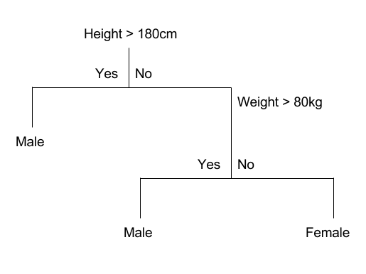
One example of the CART algorithm being used is an investigation made 10 years ago by the DG Vaishnav College in Tamil Nadu, India. Where researchers made a CART model to determine and classify blood donors according to the amount of times they have donated blood and how much time passes between donations. This showed that most of the people that donate higher amounts of blood are Regular Voluntary Donors, while Lapsed Voluntary Donors and New Voluntary Donors made smaller donations in terms of quantity. [2]

3.4 CHAID
The CHAID algorithm (Chi-square Automatic Interaction Detector) was first brought into attention by Gordon V. Kass in 1980. This method is used to determine and discover relationships between categorical response and predictor variables, in order to discover patterns that may be difficult to visualize in an unorganized manner. It then uses the chi-square test to measure and analyze how different the model data is compared to the expectations it had.

This method is commonly used on direct marketing to determine how a certain group of customers may respond to a campaign or advertisement made by a specific enterprise.
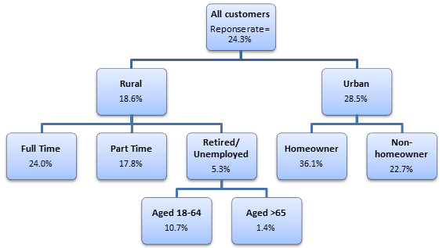

REFERENCIAS
1. Jason Brownlee. 2019. Classification And Regression Trees for Machine Learning. (August 2019). Retrieved February 9, 2020 from https://machinelearningmastery.com/classification-and-regression-trees-for-machine-learning/
2. T. Santhanam and Shyam Sundaram. Application of CART Algorithm in Blood Donors Classification. Journal of Computer Science 6, Tamil Nadu, 2010 from http://citeseerx.ist.psu.edu/viewdoc/download?doi=10.1.1.165.8749&rep=rep1&type=pdf
3. Sarah Littler. 2018. CHAID (Chi-square Automatic Interaction Detector). (May 2018). Retrieved February 9, 2020 from https://select-statistics.co.uk/blog/chaid-chi-square-automatic-interaction-detector/
4. Sefik Serengil. 2017. A Step by Step ID3 Decision Tree Example. (November 2017). Retrieved February 9, 2020 from https://sefiks.com/2017/11/20/a-step-by-step-id3-decision-tree-example/
5. Sefik Serengil. 2018. A Step By Step C4.5 Decision Tree Example. (May 2018). Retrieved February 9, 2020 from https://sefiks.com/2018/05/13/a-step-by-step-c4-5-decision-tree-example/

